**Lab 06 TASKS (LOOPS)**

Q.1) Write a program that find the sum of all the digits from 1 to given number using for loop?

**Source Code:**

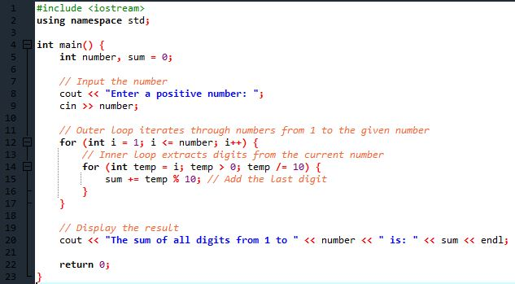

**Output:**

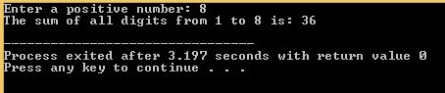

Q.2) Write a program that find the even upto a given number and add all the those even numbers using while loop?

**Source Code:**

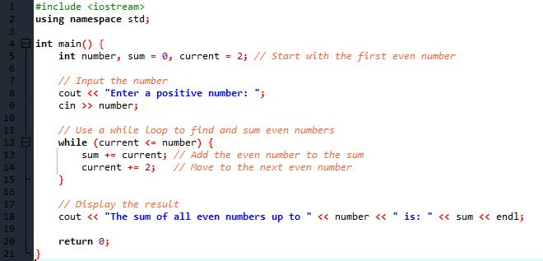

**Output:**

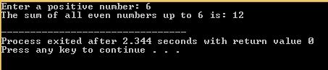

Q.3) Write a program that find the even upto a given number and add all the those even numbers using do-while loop?

**Source Code:**

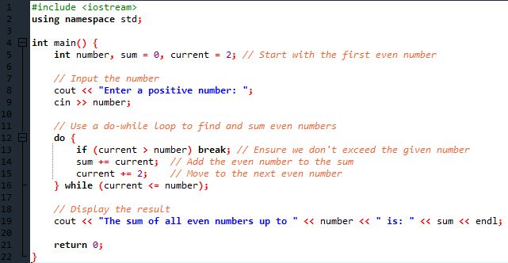

**Output:**

